# **Orange Pi One ubuntu linux and android mini PC Beyond and Compatible with Raspberry Pi 2**

### **What’s Orange Pi One?**

It’s an open-source single-board computer. It can run Android 4.4, Ubuntu, Debian, Rasberry Pi Image. It uses the AllWinner H3 SoC, and has 512MB DDR3 SDRAM

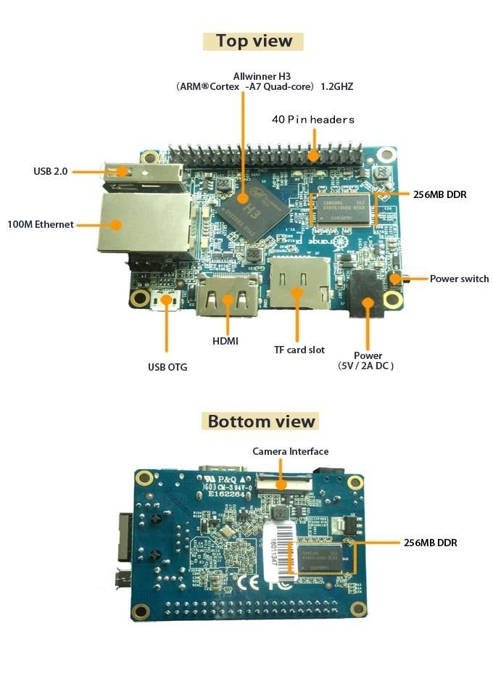

### **What can I do with Orange Pi One?**

Build…

* A computer
* A wireless server
* Games
* Music and sounds
* HD video
* A speaker
* Android
* Scratch
* Pretty much anything else, because Orange Pi is open source

### **Who’s it for?**

Orange Pi One is for anyone who wants to start creating with technology – not just consuming it. It's a simple, fun, useful tool that you can use to start taking control of the world around you.

| Hardware specification | | |
| --- | --- | --- |
| CPU | H3 Quad-core Cortex-A7 H.265/HEVC 4K | |
| GPU | ·Mali400MP2 GPU @600MHz    ·Supports OpenGL ES 2.0 | |
| Memory (SDRAM) | 512MB DDR3 (shared with GPU) | |
| Onboard Storage | TF card (Max. 64GB) / MMC card slot | |
| Onboard Network | 10/100 Ethernet RJ45 | |
| Video Input | A CSI input connector Camera:    Supports 8-bit YUV422 CMOS sensor interface    Supports CCIR656 protocol for NTSC and PAL    Supports SM pixel camera sensor    Supports video capture solution up to 1080p@30fps | |
| Audio Input | No | |
| Video Outputs | Supports HDMI output with HDCP    Supports HDMI CEC    Supports HDMI 30 function | |
| Audio Output | HDMI | |
| Power Source | DC input, USB OTG input don't supply power | |
| USB 2.0 Ports | One USB 2.0 HOST, one USB 2.0 OTG | |
| Buttons | Power button | |
| Low-level peripherals | 40 Pins Header,compatible with Raspberry Pi B+ | |
| GPIO(1x3) pin | UART,ground. | |
| LED | Power led & Status led | |
| Key | POWER | |
| Supported OS | Android Lubuntu, Debian, Rasberry Pi Image | |
| Interface definition | | |
| Product size | | 69mm × 48mm |
| Weight | | 36g |
| Orange Pi™ is a trademark of the Shenzhen Xunlong Software CO., Limited | | |

Sale contact:

zhao_stevenAT263.net (Consulting service)

Attention Twitter:orangepixunlong

skype: zhaoyifan_steven

Facebook: +8613632793025

Google+:steven.zhaoyifanATgmail.com